Investigating Barbie

The purpose of this activity is to allow students to become familiar with key concepts and core learning outcomes integrated
Your task is to investigate fashion dolls Barbie and Ken. During this activity you will be concentrating on exploring Barbie, her lifestyle and values and we will use this information to analyse the effect Barbie has had on society.

Your task will be to analyse Barbie’s effect on Society. You will be required to write an analytical exposition. You will need to state your opinion about Barbie and use arguments (facts, data, evidence) to support your opinion.

Investigating

Does Barbie represent a real woman?
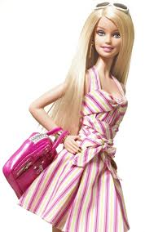
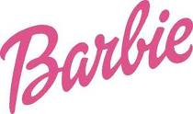
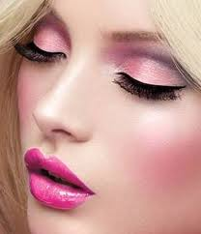
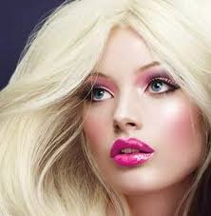
NO! The measurements of barbie’s body is nothing like the average woman. For example, based on the ratio used, her waist was 45cm but the average human’s waist was 85 cm.

Is Ken the average man?
NO! The measurements of Ken’s body is nothing like the average man. For example, based on the ratio used, his leg length was 384.9cm but the average man’s leg length is 97 cm.

We can use mathematics to solve this question
The following table lists the measurements for an “average” woman and the average man.
How can we use mathematics to find out if Barbie’s or Ken’s measurements are a true representation to that of an average woman or man?
We should measure a barbie doll.

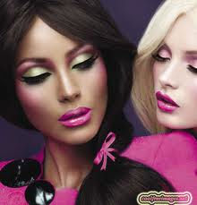
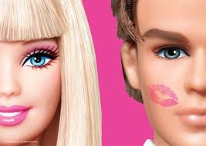
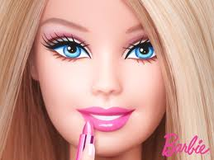
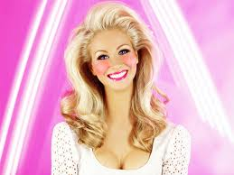
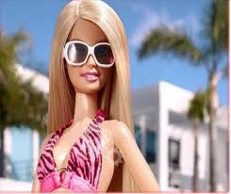
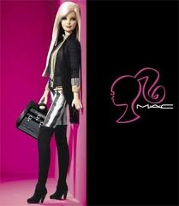
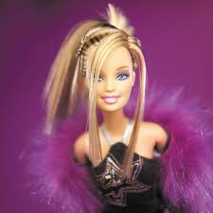
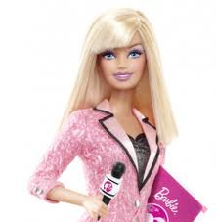
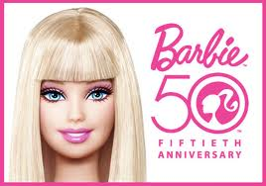
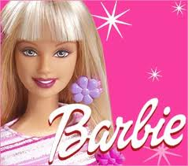
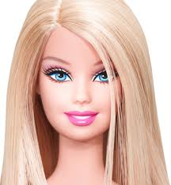

Barbie/Ken’s actual measurements  Doll Height Projected  Height  Barbie Ken Barbie Ken |  |  |  |  | Measurements  of an “average woman” |  | Measurements of an “average man”
Height | 31cm | 31cm | 157 | 157 | Height | 157cm | Height | 168cm
Waist | waist 3.5ins (8.9cm) | 4.5" 12.2cm | 45.1 | 61.8 | Waist | 85 cm | Waist | 105 cm
Hips | hips 5in (12.7cm) | 6"  15.0 cm | 60.8 | 75.7 | Hips | 109cm | Hips | 107 cm
Upper Leg | 25 cm | 27 cm | 126.6 | 136.7 | Upper Leg | 32cm | Upper Leg | 36 cm
Inner thigh | 50 cm | 55 cm | 253.2 | 278.5 | Inner thigh | 64cm | Inner thigh | 61 cm
Arm Length | 4" (100 mm) | 4.5"  12.2 | 107.6 | 61.8 | Arm Length | 46cm | Arm Length | 66 cm
Leg Length | 76 cm | 76 cm | 384.9 | 384.9 | Leg Length | 71cm | Leg Length | 97 cm

We can use a ratio formula to solve this problem. For example:-

Height ratio is 31cm : 157. If we wish to make an equivalent ratio we need to divide
157 by 31 cm, the answer equals 5.0645. So to make Barbie our size we simply multiply
her height (31cm) by 5.0645 so Barbie height measurement is projected to be the height of an average woman.

Step 1. Draw the above table in your notebook.

Step 2. Measure Barbie’s waist ............ now multiply that measurement by 5.0645 to gain a projected measurement for a woman.

Barbie Ken

Height: 31 * 5.0645 = 157 cm Height: 31* 5.0645 = 157 cm
Waist: 8.9 * 5.0645 = 45.1cm Waist: 12.2* 5.0645 = 61.8 cm
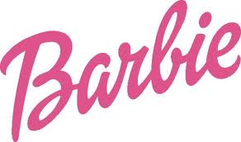
Hips: 12.7* 5.0645 = 60.8 cm Hips: 15.0* 5.0645 = 75.7cm
Upper Leg: 25* 5.0645 = 126.6 cm Upper Leg: 27*5.0645=136.7cm
Inner Thigh: 50* 5.0645 = 253.2 cm Inner Thigh: 55* 5.0645 = 278.5
Arm length: 40* 5.0645 = 107.6 cm Arm length: 12.2* 5.0645= 61.8
Leg length: 76* 5.0645 = 384.9 cm Leg length: 76* 5.0645= 384.9

All measurements are rounded to one decimal place
all measurements in cm.

Step 3. Repeat this process for all Barbie’s measurements and then Ken’s measurements, so you will be in a position to make an analysis later in this session.

You will need to carefully measure Barbie and Ken, gather data on all their measurements so that you can work out mathematically their projected measurements.

- Many young women believe that they are overweight. Do you consider that Barbie is overweight?

According to research by the University Central Hospital in Helsinki, Finland, Barbie has a BMI of 16.24. Any BMI under 18.5 is considered under weight.

- How would you describe Barbie’s body?
Barbie fits the weight criteria for anorexia and her body is disproportional.

- What eating habits do you consider that Barbie has established, remembering that she is a forty year old woman?
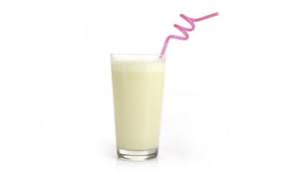
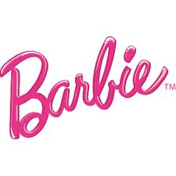
Well all she eats is sugar and cake so i would say that she is very non-nutrtional.

- Barbie believes that the secret to her controlling her weight is that she
makes the best banana smoothies in town. She uses banana, milk and low-fat vanilla ice cream in the ratio of 2: 4: 1. What mass of each ingredient will be needed to make a 630 g smoothie?

- Using Barbie’s measurements, scale up to real size (as above) then make a life-size cut out of what you think she’d be. (Do this one with a partner!)

Barbie also loves chocolate crackles. The recipe calls for:
- 2 cups of rice bubbles
- 2 Tablespoons of cocoa
- cup of coconut
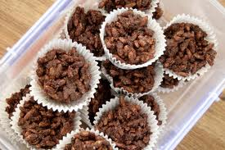
- cup of icing sugar
- 100 g of copha

(a)State the ingredients required to make 72 chocolate crackles:

- How much of each ingredient is needed to make 12?

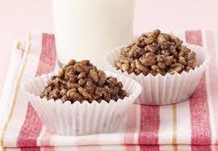

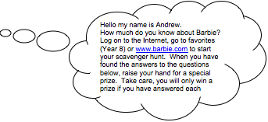
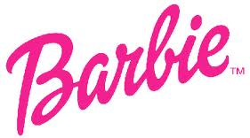
divide all of the answers from before by 6 because 72 is a actor of 12.
OK!

DID IT!!

Draw the following table using Microsoft word. Print a copy of this table before you start your internet hunt.

Questions | Answers
1.  What is Barbie’s full name? | Barbie' Millicent Roberts
2.  What year was Barbie born? | March 9, 1959

3.  Who manufactures Barbie? | Mattel
4.  Who is Ruth Handler? | The person who created barbie and based it on her daughter.
5.  What city and state is Barbie from? | America
6.  Barbie was first introduced at an annual Toy Fair. In which  American city is the Toy fair held? | New York on March 9, 1959.
7.  Which British rock band encouraged Mattel to bring the hemline of Barbie’s dress up and her hair way down? | I am not sure but i think John Marwood Cleese.
8.  Who is Barbie’s boyfriend? In which year was Barbie’s boyfriend introduced? | Ken is the boyfriend and he was intrduced in 1961.
9.  Describe the first Barbie doll to be manufactured. | The first barbie doll had an aphro hair style she has blue eyes and blue eye shdow and has red lipstick on.
10.  Who were Barbie and Ken dolls named after? | Barbra Millicent Roberts and Ken Sean Carson
11.  Barbie has become a role model to girls all over the world. Name five (5) occupations Barbie has had since her creation in 1959. | Olympic swimmer  McDonnell's cashier  waiter  DJ  singer
12.  How many careers has Barbie had since her creation in 1959? | 255

13.  Name three (3) members of Barbie’s family. | Francie(cousin),skipper(sister),todd(brother)
14.  What famous fashion magazine did Barbie make an appearance in 1997?  15.  Barbie has friends from a variety of backgrounds and from all over the world. Name four (4) of her friends. | Vogue  Merlia  Blaire  Nicholas  lila
16.  What is the name of the limited edition Barbie doll inspired by the art of Vincent  Van Gough? | "The Starry Night." She wears a strapless cocktail dress with a Cypress tree accent in black flock fabric, and the swirling patterns of the painting are echoed in her circular earrings, molded metallic sandals, and wavy hair.
17.  What change occurred to Barbie doll’s body in 1965? | she started to have a bigger and more normal waist.
18.  How has Barbie embraced new technology? | by making her beautiful and looking perfect.
19.  What is the name of the Barbie doll dressed as a man? | Michael jackson, Justin Bieber or Ken.
20.  What was the all-time-best selling Barbie doll? | Tropical Barbie  Mermaid Barbie  Swimming Barbie  Beach holiday Barbie
Using the responses from your internet search, answer the following questions in your notebook. Remember to use complete sentences.

- List the occupations Barbie has had.
swimmer, singer, dolphin coach, doctor, vet.

- What do these jobs tell you about her?
that she could do everything and was perfect.
- How is Barbie different from traditional dolls?
she is very plastic and is very sexy in what she wear unlike traditional dolls.
Why do you think so? i think so because traditional dogs wear nice long or short ruffly pretty dresses and barbie does sometimes but not often.
- Why do you think she is designed as she is?
she is designed to be so people use her as the perfect role model but also just used for money and business.
- Why do you think Barbie introduced a Hispanic doll called Christie?
To make so that it wasn't only blonde people could be pretty and to have black and white dolls also for business.
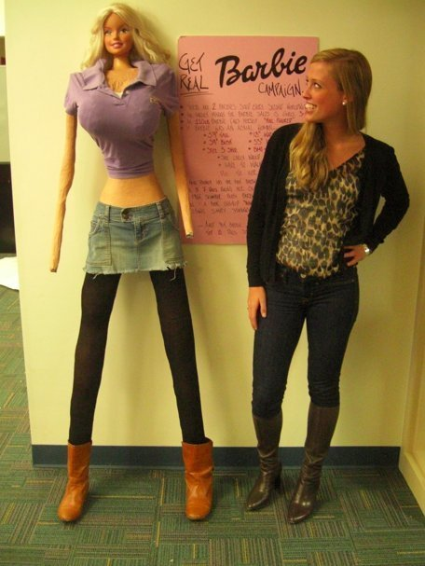
- What sort of image does Barbie project?
A big boobed, plastic surgeried, small waist, skinny like anorexic, pretty face, and perfect body.
- What does Barbie seem to value most in life?
her boyfriend KEN and her riches and appearance.
- Why might Mattel have given her these values?
maybe because they want other people to notice them and think that barbie is special and should be recognized.
- Would you say that Barbie is representative of an average woman, if not why not?
no because her body proportions are nothing like women's normal and average body, so she is probably more a fake.

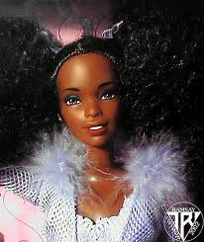
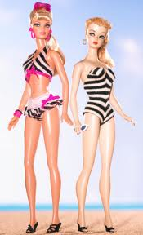
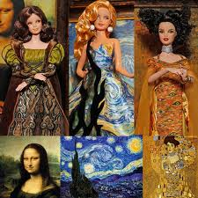
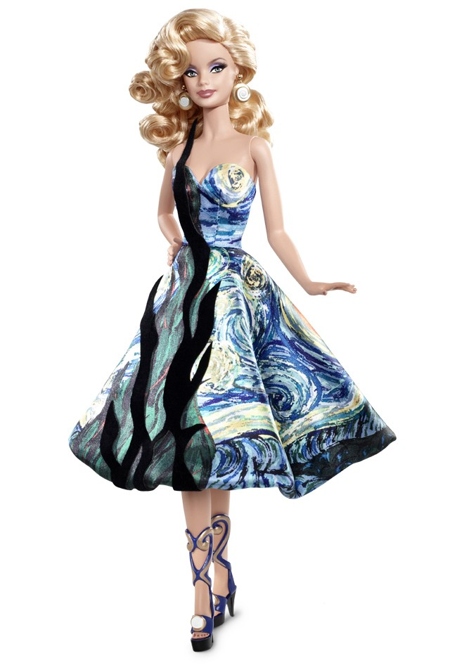
Vincent Van Gogh
Barbie doll
First Barbie doll
Barbie doll now
Christie
first black doll
Famous barbie dolls

Analysis

- Barbie is young, single, successful, thin, white, Anglo-Saxon Celtic do you think Barbie is representative of women in general? If no why not? I think no because barbie is to plastic and perfect.

- Do all women aspire to create the lifestyle and status that Barbie strives for?
i think so because they all think she is so pretty and skinny and all the boy’s like her so that is mostly what girls want so they alway say i would love to be like Barbie.

- Redraw the quality of life matrix. In the left-hand column of your table you will see eight points of contrast we could make between the life of Barbie and the lives of “average women”

Place a red dot or tick where you think Barbie’s quality of life is and place a blue dot or tick where you think the average women’s is.


Quality of Life Matrix

Points of contrast | Scale of quality  Very Poor Excellent  1 2 3 4 5
Job opportunities
Wealth
Housing
Health
Housework
Having a family
Education
Food

- How is Barbie’s life different from that of an “average woman”?
well barbie has many opportunities and is very rich so she really has nothing to worry about she can do what ever she wants but on a percentage scale Barbie is 100% and we are around 50% or 85% or 95%.
- Which “woman” has the most power over her life? (Barbie or the average woman)
well barbie is a doll so she does not have much power over her life so i would say that an average women has a lot more power over her life.

- Do all women in Australia share the same lifestyle and status? Explore in your group the differences in conditions for different groups of woman in Australia, such as for example Aboriginal women, migrant woman, Samoan Women, rural woman?

i think most women in australia probably do not share the same lifestyle because everybody leads their own life technically speaking nobody can have the same life some are rich and some are poor we are all different.

- From your current studies, describe a habitat of Barbie. Describe this habitat in a paragraph. How has Barbie adapted to the habitat you have described?
List at least 10 factors that determine what Barbie’s environment is like:
barbie would live on a beach with a huge house and make it in to her island then go off and try to marry a prince.they would then get married on the beach and have a life in there castle.
10 factors:
- rich
- pretty
- expensive
- amazing
- big
- on island or in the city
- there is always a prince she likes or boy
- animals
- has a magical creature somewhere
- A miracle always happens

- Mattel has formed a community for Barbie to exist, describe how Barbie interacts within her community. Think about the different relationships that Mattel has developed for Barbie:- e.g. Ken, Christie, Stacey. Think about the different environments that Barbie is exposed to house, ranch etc…

If barbie were real then she would probably annoyed that she is almost everywhere and how she doesn't look good in some pictures so she is probably going to be either mad or happy but on our point of view barbie is an advertisement for little kids to buy things.

- Decide whether Barbie is a producer, consumer or decomposer. Justify your answer.
i would think barbie is a producer because with all the money she has she would probably use it to deposit money for a movie.

- Describe what you think would happen if:

- other types of dolls ceased to exist
Barbie would always be at the top because she is a classic.
- Barbie Dolls increased
Barbie might be forgotten but people would inventually go back to history and see the old barbie doll how we do.
- The demand for Barbie dolls suddenly decreased
Barbie would go down and not be remembered or be the top barbie doll and have no competition.
- If Barbie was to die out, explain what would have happened. Justify your response with knowledge gained from your current studies
i dont think barbie will ever die they will just come out with new versions but if she did then they would just come up with something else.
- What are the good and bad things about Barbie? Draw a table to summarise these points.

Activity – P.M.I. – Plus Minus
Good | Bad
She is beautiful | She is anorexic
she is a role model | Is so plastic
she is rich | is a bad influence
she is skinny
she is famous

- Generate a list of introduced dolls that have invaded Barbie’s environment. Think about Cabbage Patch Dolls, generic fashion dolls, Baby Born:
Bratz, Vodu dolls, fashion instinct, cabbage patch dolls, baby born, american girl dolls.

2. Barbie belongs to a species, that is the Doll species. List some of the common characteristics that Barbie has?
SHE IS: vet,mermaid,princess,duchess,etc...
- Mattel decided in 1959 that sales within the Doll specie was slowing, describe some of the adaptations that Mattel made to the sub-specie Barbie so that she would be competitive in the doll market.

- What would happen to the Doll specie if Barbie became the only doll to be manufactured?
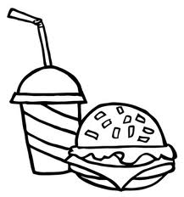
then everybody would by that doll making there company go up higher and have a lot of money making barbie the most popular.

Generate a short report (250 –300 words) on what you have learnt today.

Activity 17 “Building a Big Mac”- Writing a Report

1.Topic Sentence
- Who is Barbie?
- Write a short description of Barbie and her lifestyle?
- What will you be discussing in your report today?
2.
Who is Barbie?
Barbie is a fashion doll manufactured by the American toy-company Mattel, Inc. and launched in March 1959. American businesswoman Ruth Handler is credited with the creation of the doll using a German doll called Bild Lilli as her inspiration.
Write a short description of Barbie and her lifestyle?
Barbie is a plastic big boobed doll and is super skinny. Barbie is rich and has a prince with her wherever she goes.
What will you be discussing in your report today?
Who barbie is?
what this assessment was about?
Why is barbie important?
How hard/easy was this assessment to finish?

Body of Report
- What are the facts I will be explaining about Barbie?
- What are the interesting things about Barbie?
- How did I use mathematics to find out things about Barbie?
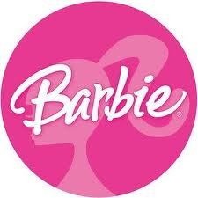
- What did I learn about Barbie’s social life compared with the average woman?
- How did I use science to find out things about Barbie?

3.Conclusion
- what did you learn today?
- what opinion have you formed about Barbie’s influence on society
- Justify your response with facts

Barbie Report

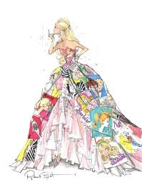
WHO IS BARBIE? The Barbie doll was created by Ruth Handler for the Mattel company in 1959. Handler and her husband, Elliot, founded the company with partner Harold "Matt" Matson in 1942. Ruth, inspired by dolls she'd seen on a trip to Europe, and from watching her own daughter, Barbara, created an adult doll for children. Twelve inches high and plastic, the new "Barbie" doll and her fashionable and separately-sold clothing were such a hit that Mattel became a publicly-owned company in 1960. New versions of the toy mirrored fashion trends over the years, and Barbie was the center of a universe that included a benign boyfriend (Ken), occasional siblings (Skipper, Todd, Stacie, et al), pets (too many to name, including dogs, horses, cats and a parrot), cars, boats, planes and houses. Special versions of Barbie included scientists, disco dancers, fashion models, astronauts, rock stars and lifeguards. By the 1980s the doll's force as a collectible was such that Mattel began making versions of Barbie specifically for the collectors' market. Critics of the doll say it presents an unrealistic body image for girls, pointing to Barbie's large bosom, slim waist, long legs, white skin and blonde tresses. Fans say Barbie encourages young girls and boys by giving them aspirations to be scientists, disco dancers, fashion models, astronauts, rock stars or lifeguards. Despite the ongoing debate over Barbie's impact on American culture, the doll remains one of the best-known and best-selling dolls on the market.
what this assessment was about?
This assessment was about the history of barbie but connected to math by the measurements and ratio’s so it has to do with math and barbie.
Why is Barbie Important?
Barbie is important for kids because its like entertainment and is just fun for them to play with.

Conclusion:
I thought this was a very fun exercise but the life size barbie was or is really hard but I had lots of fun with this assessment and hope i get a good grade.

Barbie
By: Amber McKenzie
Class: MYP 2
Subject: Math

Bibliography:
http://moodle.codrington.edu.bb:81/course/view.php?id=162
http://news.bbc.co.uk/2/hi/uk_news/magazine/7920962.stm
http://en.wikipedia.org/wiki/Barbie
http://www.huffingtonpost.com/galia-slayen/the-scary-reality-of-a-re_b_845239.html
http://www.fashionwindows.net/2010/10/looking-for-a-genuine-ken/
http://www.knitting-and.com/knitting/tips/doll-sizes.htm
http://www.huffingtonpost.com/galia-slayen/the-scary-reality-of-a-re_b_845239.html
http://www.nhlbisupport.com/bmi/
http://en.wikipedia.org/wiki/Barbie

